**CG-Assignment**

**Koch Curve**

**Program:**

Writing a program to print Koch Curve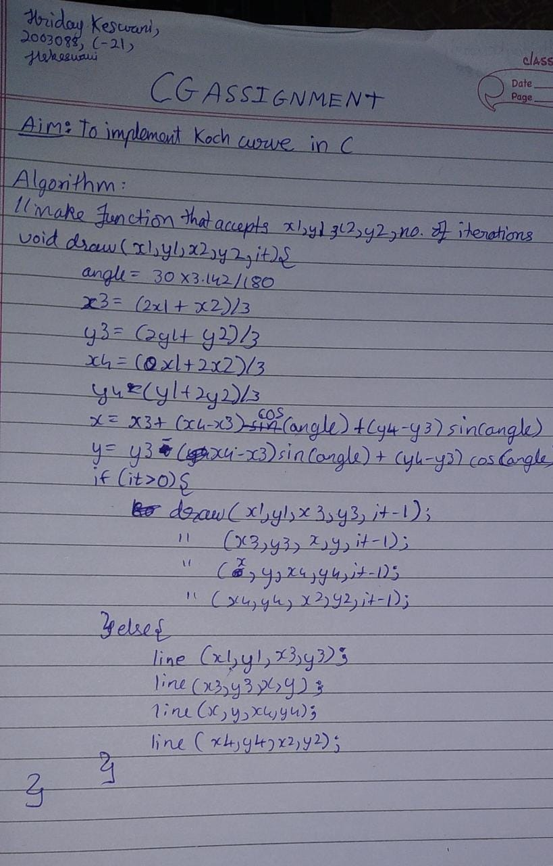

**Code:**

#include<stdio.h>

#include<graphics.h>

#include<math.h>

#include<conio.h>

void koch(int x1, int y1, int x2, int y2, int iteration)

{

float angle = 60*M_PI/180;

int x3 = (2*x1+x2)/3;

int y3 = (2*y1+y2)/3;

int x4 = (x1+2*x2)/3;

int y4 = (y1+2*y2)/3;

int x = x3 + (x4-x3)*cos(angle)+(y4-y3)*sin(angle);

int y = y3 - (x4-x3)*sin(angle)+(y4-y3)*cos(angle);

if(iteration > 0)

{

koch(x1, y1, x3, y3, iteration-1);

koch(x3, y3, x, y, iteration-1);

koch(x, y, x4, y4, iteration-1);

koch(x4, y4, x2, y2, iteration-1);

}

else

{

line(x1, y1, x3, y3);

line(x3, y3, x, y);

line(x, y, x4, y4);

line(x4, y4, x2, y2);

}

}

void main(){

int gd = DETECT,gm;

int x1,y1,x2,y2;

initgraph(&gd,&gm,"c:\\turboc3\\bgi");

printf("Enter the starting and ending coordinates:\n");

scanf("%d%d%d%d",&x1,&y1,&x2,&y2);

koch(x1, y1, x2, y2, 3);

printf("\n\n\nHriday Keswani\nC-21\n2003088\n");

getch();

closegraph();

}

**Output:**

